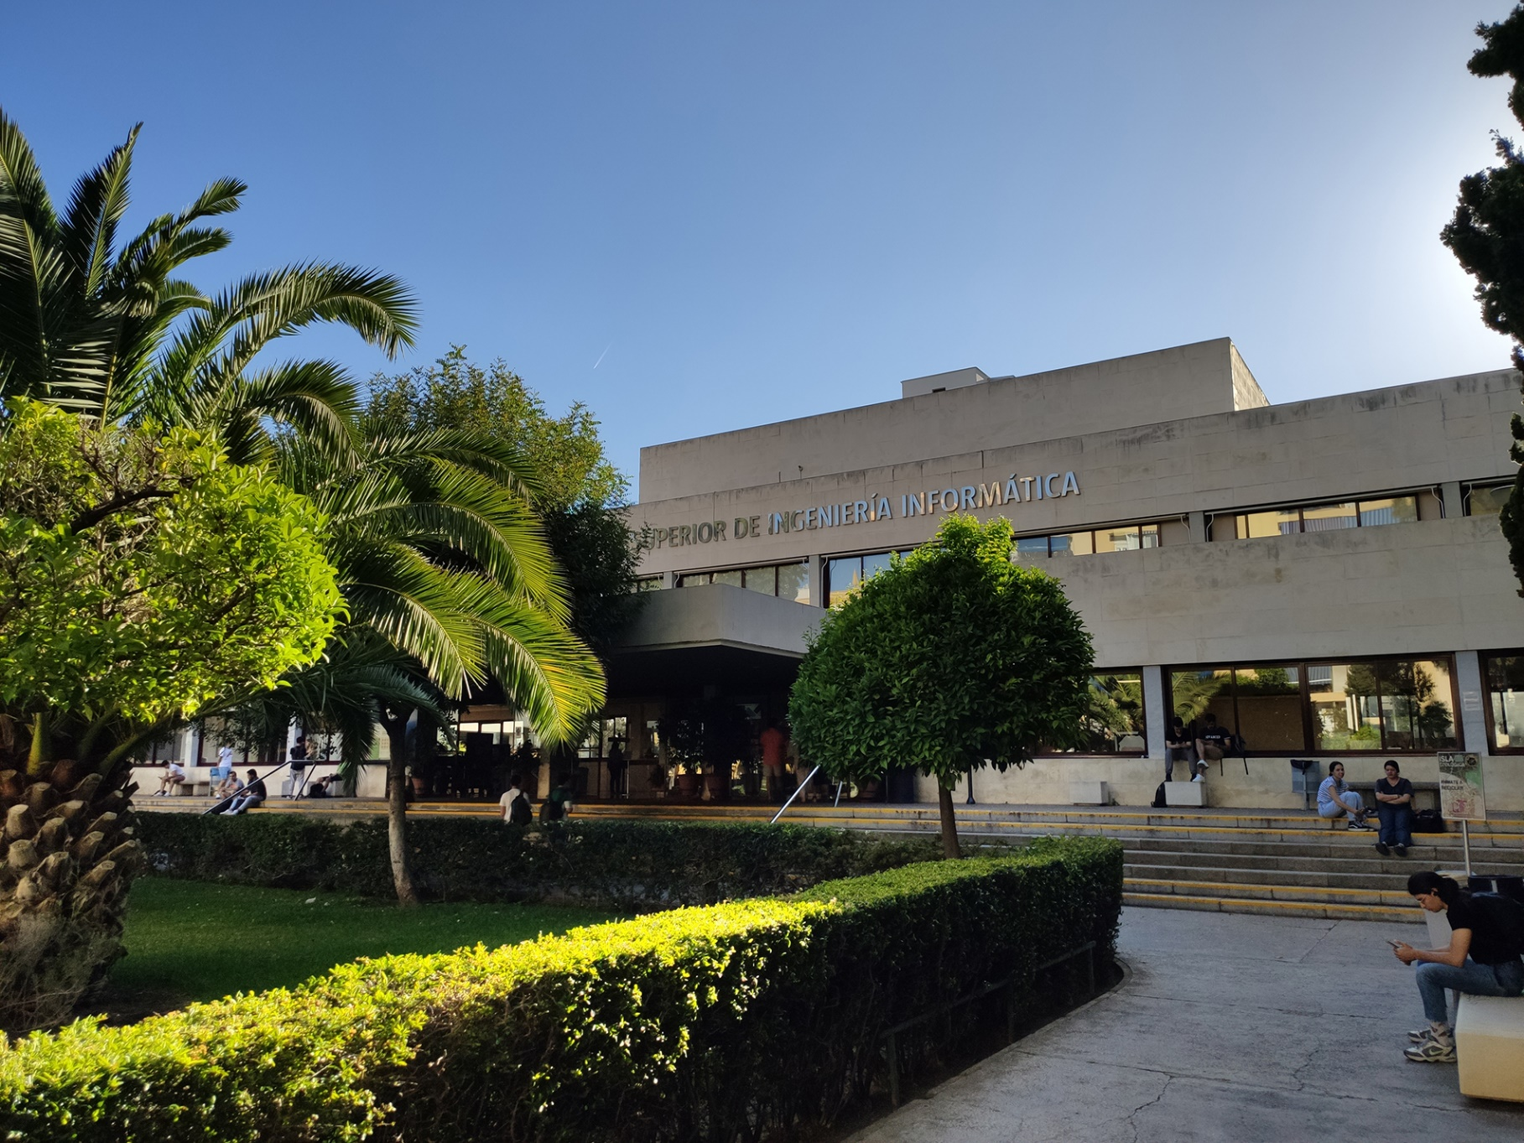

|  |
| --- |
| Planning Report |
| Jesús Cárdenas Conejo  (jescarcon@alum.us.es) |
| 8-03-2023  Group: C1.02.10  Repository: https://github.com/IsmaelRuizJurado/Acme-L3-D02 |



Table of Contents

Executive Summary 3

Version History 4

Introduction 5

Contents 6

Conclusions 7

Bibliography 8

# Executive Summary

In this document you will find relative information about how is my assigned part of the project split in tasks, I decide to write it in a table where you can find for every task : His Title, Succinct Description, Role/s , Planned Time and Actual Time then I calculate the price of the work done

# Version History

|  |  |  |
| --- | --- | --- |
| Version | Date | Description of changes |
| 1.0 | 8/03/2023 | Creation of the document |

# Introduction

In this document I introduce a table for the tasks of the project. Every new row includes the title of the task, a succinct description of the task , the role assigned , the planned time for doing the task and the final time for that task. At the final column is calculated the cost of that task.

The cost stablished for the task is 30 €/h for the manager and analyst tasks and 20 € for the developer ones.

# Contents

|  |  |  |  |  |  |
| --- | --- | --- | --- | --- | --- |
| Title | Succinct Description | Role/s | Planned Time | Actual Time | Cost |
| Group Task: UML Domain Model | Create an UML  with all the elements needed for the D02-Deriverable | Analyst | ~20 | - | € |
| Group Task: Offer Entity | And entity created by an administrator with : moment, a heading ,summary ,availability period, a price and an optional link. | Developer | ~20 | 23’ | 7,7€ |
| Individual Task:Create the rol Lecturer | Create Lecturer role with the following parameters: alma mater a résumé , list of qualifications ,and an optional link | Developer | ~20 | 16’ | 5,3€ |
| Individual Task:Create the Entity Course | A course with the following data about them: a code,a title,an abstract, a type(theory , hands-on),a retail price and an optional link | Developer | ~20 | 7’ | 2,3€ |
| Individual Task:Create the Entity Lecture | A Lecture with the following data : a title ,an abstract, an learning time ,a body, a type(theory , hands-on), and an optional link | Developer | ~20 | 5’ | 1.7€ |
| Individual Task:Create Lecturer Dashboard | The system must handle lecturer dashboards with the following data: total number of theory and hands-on lectures; average, deviation, minimum, and maximum learning time of the lectures; average, deviation, minimum, and maximum learning time of the courses | Developer | ~20 | 5’ | 1.7€ |
| Individual Task:Create test users | Create sample data test.Lecturer accounts with credentials “lecturer1/lecturer1”and “lecturer2/lecturer2”. | Developer | ~25 | - | € |
| Analysis Report | Create Analysis Report | Analyst | ~25’ | 27’ | 13.5€ |
| Planning Report | Create Planning Report | Analyst | ~25’ | 15’ | 7.5€ |

# Conclusions

This table will help the group to organize tasks giving a general view of all tasks division and calculate the final cost of every single requirement.

# Bibliography

Intentionally blank.